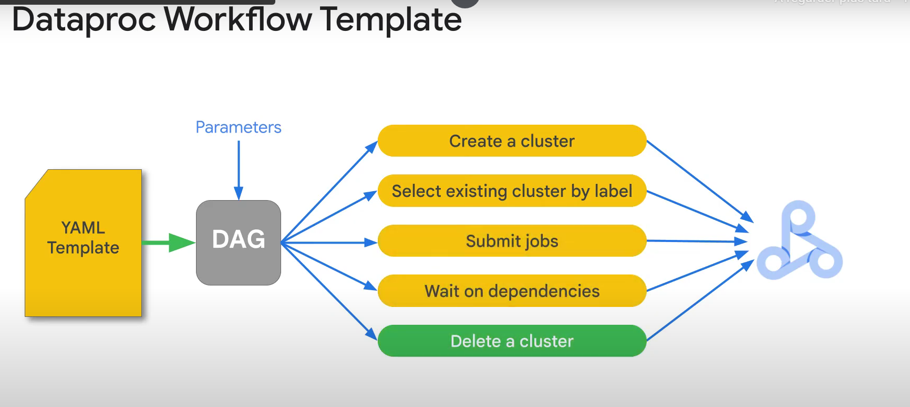

Example:

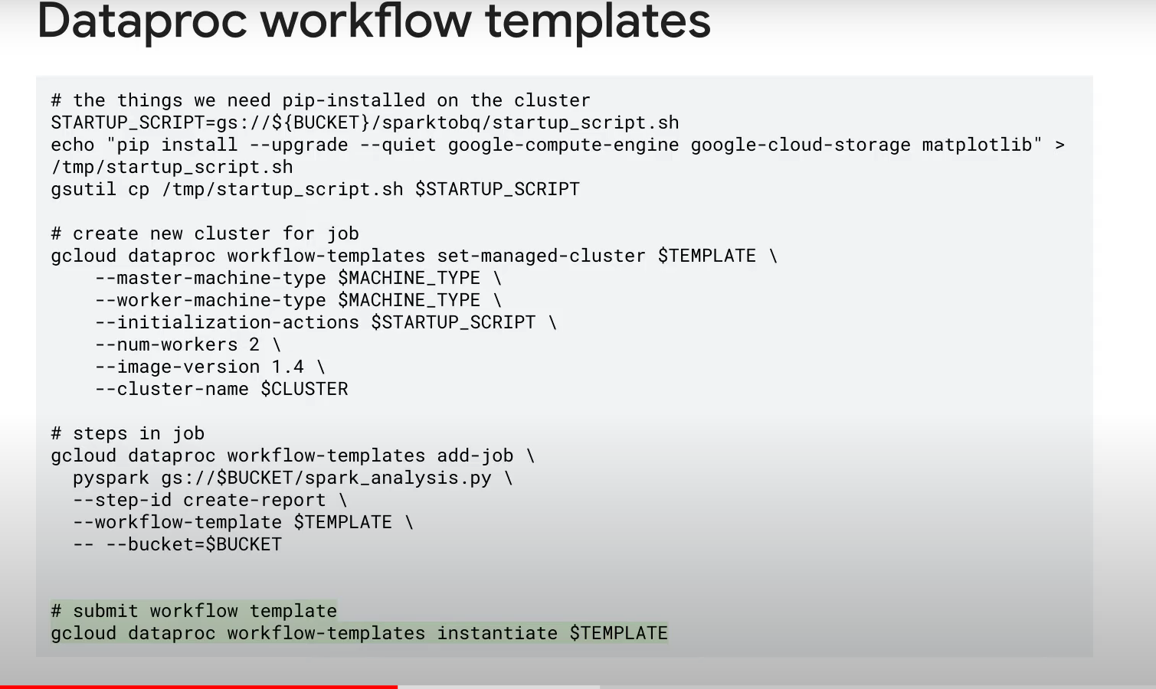

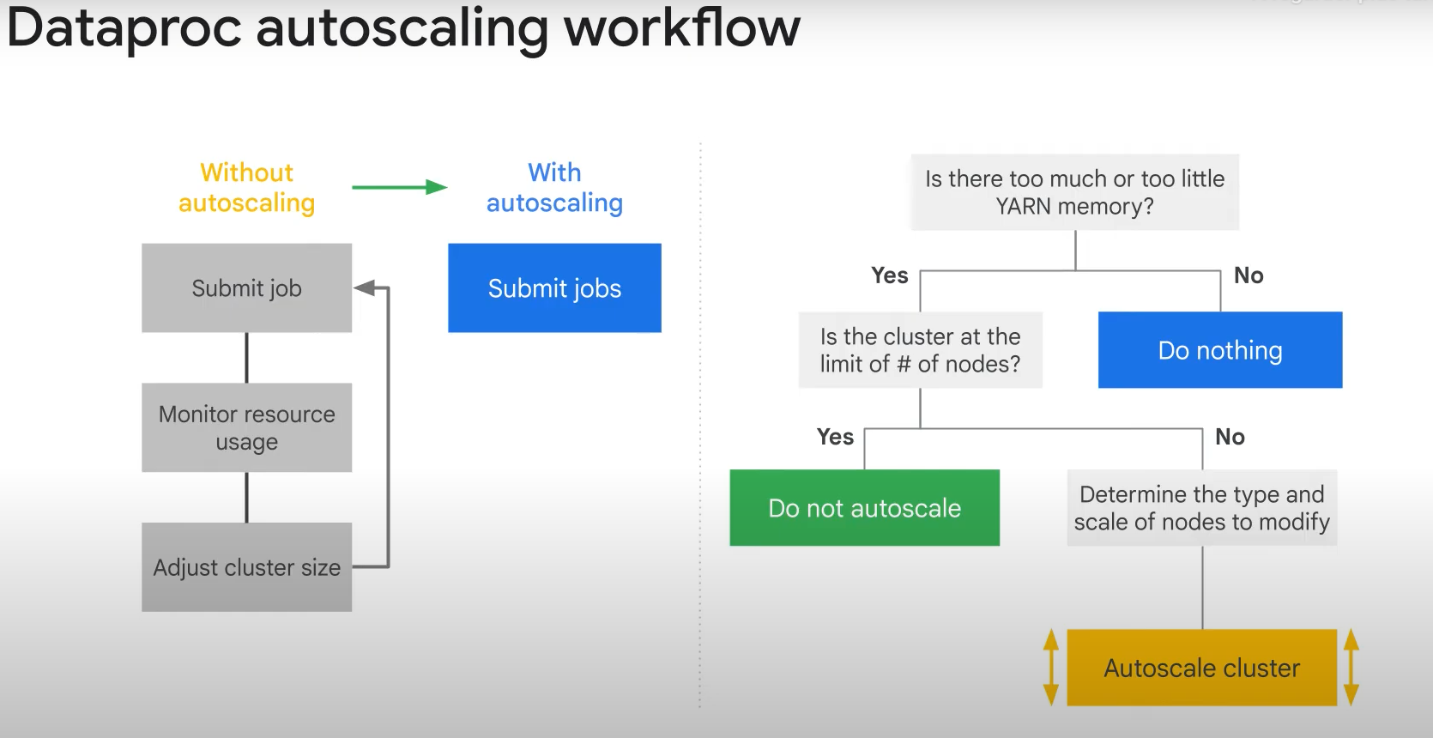

* Autoscaling process scans the clusters/jobs every 2 min!

* You can view the history of autoscaling in logs

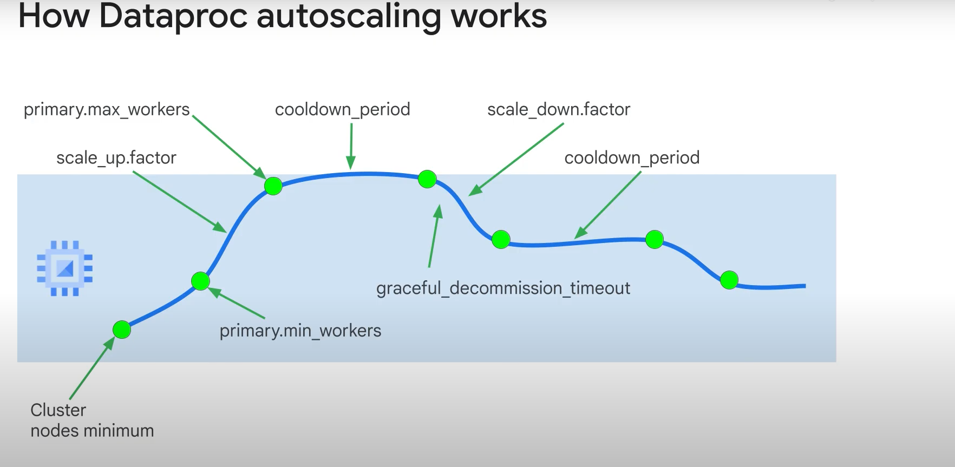

Cluster nodes minmum: we always start with this number of workers.

Scale_up.factor: how many nodes to launch when we need more ressources. Usually it’s 1 node, but if you know we’ll have peaks of activity, you can increase it.

Graceful_decomission_timeout: we give running jobs the chance to compelete before the extra nodes get disabled.